[**How to delete a list or library**](https://sharepoint.rackspace.com/learning/articles/Pages/SharePoint-2013--how-to-delete-a-list-or-library.aspx)

1. On your SharePoint 2013 home page, **open any list or library**, in this example I will open the Documents library.

2. From the Documents library, at the top of the page click **Library** to expand the ribbon.  
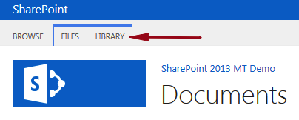

3. On the far right of the ribbon click **Library Settings**.

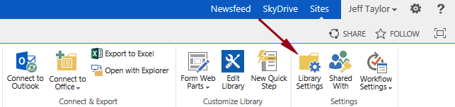

4. Under Permissions and Management click **Delete this document library**.

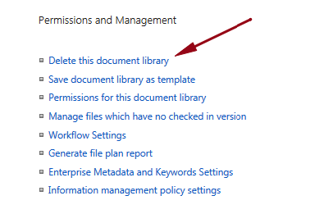  
5. It’s going to ask you “This document library will be removed and all its files will be deleted.  Are you sure you want to send this document library to the site Recycle Bin?” Click **OK**.

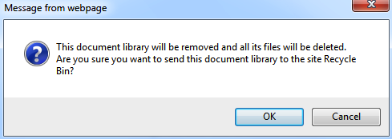

Thats it! The Documents library has been deleted.

2. For List

* Site contents
* Contact
* List
* List setting
* Delete this list
* ok